ABOVEGROUND STORAGE TANK
API 653 INSPECTION REPORT

FORMAL (INTERNAL/EXTERNAL) INSPECTION

{#cover}
{company_name}

TANK {tank_no}

{terminal}

{location}

{insp_date} (Month DD, YYYY)

Prepared by:

(LOGO)

Inspection Company Name
1001 Anywhere Drive
City, ST 12345 USA
(123) 456-7890

Revisions:
Rev. 1, MM/DD/YY {/cover}

INTRODUCTION

{#intro}{company_name} contracted with Dexon Technology PLC to provide API 653 Formal {insp_campaign} Inspection for the aboveground storage tank {tank_no} at the {terminal} in {location}.

The inspection was carried out by a team of inspectors under the supervision of a certified API 653 inspector during (insp_date)June 10, 2022.

Dexon Technology PLC deployed the following personnel to execute the task and prepare inspection report for submission to client.

Inspection Co. provided the following personnel:

{name_api_653}
API 653 Inspector
Certification Number {cert_no}

{name_inspection_engineer}
Inspection Engineer

{name_ndt_examiner}
NDT Examiner
{/intro}

SUITABILITY FOR SERVICE

{#suitability}According to Section 9.0 of the {company_name}Technical Specification for Formal External and Internal Tank Inspections of Large Aboveground Storage Tanks, Inspection Co.’s recommendation for service is categorized as Class (select 1, 2, or 3).

Tank is/is not compliant with API 653.

Tank is suitable for service if certain repairs are made or recommendations implemented…
…

It is recommended that the following items be addressed before returning the tank to service:

CLASS 1 ITEMS
- Repair …
- Coat …
- Remove …

…

In addition, while not imperative for returning the tank to service, the following items are listed for immediate consideration:

CLASS 2 ITEMS
- Repair …
- Install …

…

The following items are listed for continuous monitoring and should be reviewed during the next inspection:

CLASS 3 ITEMS
- Monitor the condition of …

…
{/suitability}
Date of next FEI: (Month DD, YYYY)
Date of next FII: (Month DD, YYYY)
Limiting component: (bottom, shell, roof, etc.)

TABLE OF CONTENTS

INTRODUCTION 2
SUITABILITY FOR SERVICE 3
1 DETAILED TANK INFORMATION 7
1.1 General 7
1.2 Dimensions 7
1.3 Components 7
1.4 Inspection History 8
1.5 Coatings 8
1.6 Miscellaneous 8
1.7 Summary of Corrosion Rates 9
2 SUMMARY OF FINDINGS 10
2.1 Foundation 10
2.2 Bottom 10
2.3 Shell 10
2.4 Fixed Roof 10
2.5 Floating Roof 10
2.6 Nozzles and Appurtenances 10
2.7 Miscellaneous 10
3 INSPECTION DETAILS 11
3.1 Foundation 11
3.1.1 Foundation Settlement Evaluation Plot 11
3.1.2 Determination of Acceptable Differential Settlement 11
3.1.3 Foundation Settlement Survey Data 11
3.2 Bottom 12
3.2.1 Bottom Thickness Readings 12
3.2.2 Service Interval Calculation 12
3.2.3 Bottom Layout 12
3.3 Shell 12
3.3.1 Shell Thickness Readings 12
3.3.2 Shell Thickness Calculations 12
3.3.3 Shell Rollout 12
3.4 Fixed Roof 13
3.4.1 Fixed Roof Thickness Readings 13
3.4.2 Fixed Roof Nozzle Table 13
3.4.3 Fixed Roof Layout 13
3.5 Floating Roof 13
3.5.1 Floating Roof Thickness Readings 13
3.5.2 Floating Roof Nozzle Table 13
3.5.3 Floating Roof Layout 13
3.5.4 Floating Roof Seal Gap Measurement Results (U.S. only) 14
3.6 Nozzles and Appurtenances 14
3.6.1 Nozzles and Appurtenances Table 14
3.6.2 Shell Rollout 14
3.7 Corrosion Rate Information 14
3.7.1 Bottom Corrosion Rate 14
3.7.2 Shell Corrosion Rate 14
3.7.3 Fixed Roof Corrosion Rate 14
3.7.4 Floating Roof Corrosion Rate 14
3.8 Seismic Evaluation Error! Bookmark not defined.
4 NDE INSPECTION SUMMARY 16
4.1 NDE Inspection Scope 16
4.2 Significant Findings 16
4.3 Bottom Examination 16
4.4 Shell Readings 16
4.5 Fixed Roof Readings 16
4.6 Floating Roof Readings 16
4.7 Nozzle and Appurtenance Readings 16
4.8 Sump Readings 16
APPENDIX A – EQUIPMENT 17
APPENDIX B – DATA 18
APPENDIX C – DRAWINGS 19
APPENDIX D – PHOTOGRAPHS 20
APPENDIX E – CHECKLISTS 22
Appendix F – Corrosion Rate Database Error! Bookmark not defined.

DETAILED TANK INFORMATION
{#general}

General
OWNER: | {company_name}
TANK #: | {tank_no}
FACILITY TYPE: | Terminal
CITY, STATE: | {location}
YEAR BUILT: | {inservice_date}
DESIGN STANDARD: | (API #, etc…)
MANUFACTURER: | (name)
CURRENT PRODUCT STORED: | {product}
DATA PLATE PRESENT: | (Y/N)

Dimensions
DIAMETER: | {dia_m} meters
HEIGHT: | {height_m} meters
CAPACITY GROSS: | {tank_capacity_liters} liters
CAPACITY NORMAL: | [bbl]
OPERATING HEIGHT: | {max_liquid_level} meters

Components
FOUNDATION: | {foundation}
BOTTOM: | (weld type, double bottom?, annular ring?)
SHELL: | (weld type, etc.)
MANWAYS: | (number and size)
INSULATION: | {insulation}
FIXED ROOF: | {roof_shade}
ACCESS: | (vertical ladder, cat walk, etc.)
DRAIN: | (Y/N)
VENTS: | (number and type)
MANWAYS: | (number and size)
FLOATING ROOF: | (Y/N)
TYPE: | (internal or external)
MATERIAL AND STYLE: | (steel annular pontoon, aluminum, pan, …)
PRIMARY SEAL: | (type)
ALL STEEL PONTOONS SEAL WELDED? | (Y/N)
SECONDARY SEAL: | (type)
ANTI-ROTATION DEVICE: | (Y/N)
GAUGE PIPE: | (type)
ACCESS: | (rolling ladder, etc.)
DRAIN: | (Y/N)
AGE OF DRAIN (REQUIRED IF YES):
FLOATING SUCTION | (Y/N)
FLOATING SUCTION PONTOONS DRY? | (Y/N)

Inspection History
FORMAL EXTERNAL INSPECTION (FEI)
LAST INSPECTED: | (date)
LAST COATED: | (date)
LAST CLEANED: | (date)
PREVIOUSLY RECOMMENDED NEXT FEI: | (date)
FORMAL INTERNAL INSPECTION (FII)
LAST INSPECTED: | (date)
LAST COATED: | (date)
LAST CLEANED: | (date)
PREVIOUSLY RECOMMENDED NEXT FII: | (date)

Coatings
EXTERNAL
BOTTOM: | (type)
SHELL: | (type)
FIXED ROOF: | (type)
FLOATING ROOF: | (type)
INTERNAL
BOTTOM: | (type)
SHELL: | (type)
FIXED ROOF: | (type)
FLOATING ROOF: | (type)

Secondary Containment
Description / Condition / Visual Findings

Miscellaneous
PRESSURE (operating/design): | (report both)
TEMPERATURE (operating/design): | (report both)
VENTING:
FLOW RATES:
SUCTION LINE:
RECEIPT:
{/general}

SUMMARY OF FINDINGS

Foundation
(include methods employed and results obtained)

Bottom
(include methods employed and results obtained)

Critical Zone
(include methods employed and results obtained)

Shell
(include methods employed and results obtained)

Fixed Roof
(include methods employed and results obtained)

Floating Roof
(include methods employed and results obtained)

Nozzles and Appurtenances
(include methods employed and results obtained)

Secondary Containment
(include methods employed and results obtained)

Miscellaneous
(include methods employed and results obtained)

INSPECTION DETAILS

Foundation

Foundation Settlement Evaluation Plot
(example below…)
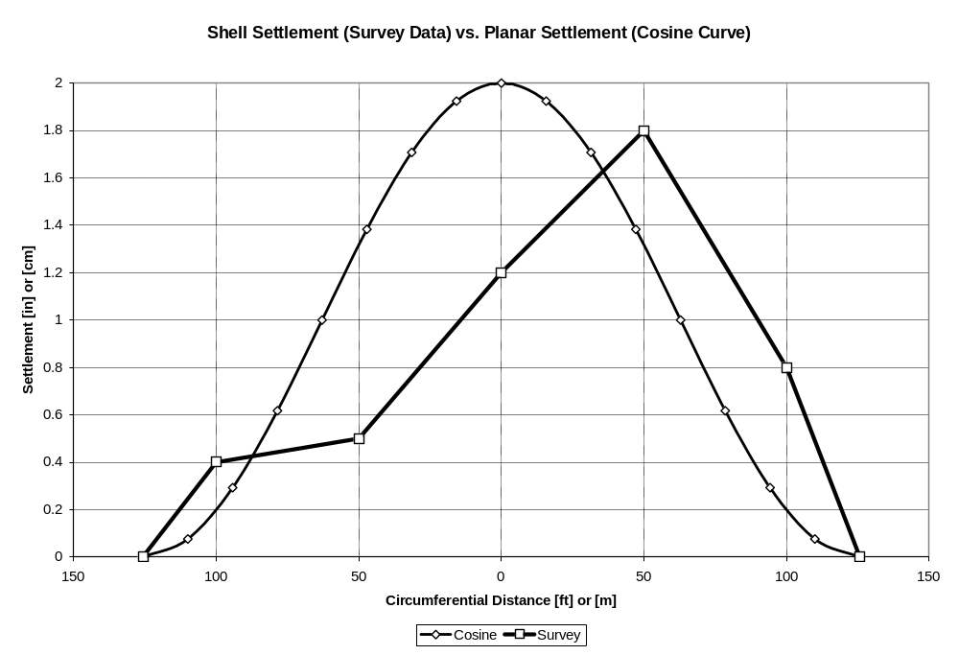

(Show additional necessary notes, tables, data, etc. in order to explain the results of the evaluation)

Determination of Acceptable Differential Settlement
(Show calculation and check according to API 653, Appendix B, B.3.2. Plot comparing calculated deflection vs. maximum allowable deflection is optional.)

Foundation Settlement Survey Data
See Appendix B for data.

Bottom

Bottom Thickness Readings
See Appendix B for data.

Service Interval Calculation
(Show calculation according to API 653, 4.4.5. Recommend the duration (in years) until next internal inspection.)

Bottom Layout
See Appendix C for drawing.
(Show plan view layout drawing of tank bottom with notable appurtenances labeled, bottom plates numbered, and appropriate reference points noted. Include all locations of pits that require repair before returning tank to service.)

Critical Zone
See Appendix B for data.

Service Interval Calculation
(Show calculation according to API 653, 4.4.5.4 Recommend the duration (in years) until next internal inspection.)

Bottom Layout
See Appendix C for drawing.
(Show plan view layout drawing of tank bottom with notable appurtenances labeled, bottom plates numbered, and appropriate reference points noted. Include all locations of critical zone findings that require repair before returning tank to service.)

Shell

Shell Thickness Reading
See Appendix B for data.

Service Interval Calculation
(Show calculation according to API 653 4.3.3.1, Recommend the duration (in years) until next internal inspection for each course.)

Shell Thickness Calculations
(Show calculations of shell thickness according to API 653, 4.3.3. Show that all reported thicknesses meet minimum required thickness level or recommend repairs. Provide necessary explanations.)

Shell Rollout
See Appendix C for drawing.
(Show elevation view rollout drawing of shell with notable appurtenances labeled, shell courses numbered, and appropriate reference points noted. Include all locations of findings that require repair before returning tank to service.)

Note: Shell circumference measurement is required. Asking any Company rep for the diameter is inadequate.

Fixed Roof

Fixed Roof Thickness Readings
See Appendix B for data.

Service Interval Calculation
(Describe evaluation according to API 653 4.2, Recommend the duration (in years) until next internal inspection given minimum roof plate thickness for CVX of 0.1”.)

Fixed Roof Nozzle Table
See Appendix B for data.
(Show table including dimensions, thicknesses, locations, and other data applying to the various fixed roof nozzles.)

Fixed Roof Layout
See Appendix C for drawing.
(Show plan view layout drawing of fixed roof with all appurtenances labeled and appropriate reference points noted. Include all locations of findings that require repair before returning tank to service.)

Floating Roof

Floating Roof Thickness Readings
See Appendix B for data.

Service Interval Calculation
(Describe evaluation according to API 653 4.2.3, Recommend the duration (in years) until next internal inspection in two modes:
1) through pitting
2) given minimum roof plate thickness for CVX of 0.1”.)

Floating Roof Nozzle Table
See Appendix B for data.
(Show table including dimensions, thicknesses, locations, and other data applying to the various floating roof nozzles.)

Floating Roof Layout
See Appendix C for drawing.
(Show plan view layout drawing of floating roof with all appurtenances labeled and appropriate reference points noted. Include all locations of findings that require repair before returning tank to service.)

Note: All appurtenance labels must also include a label consistent with “Tanks” emissions software.

Floating Roof Seal Gap Measurement Results (U.S. only)
(Report summary of measurements and results here if applicable, e.g. tanks in the United States under EPA Air Rules. Put data in Appendix B.)

Nozzles and Appurtenances

Nozzles and Appurtenances Table
See Appendix B for data.
(Show table including dimensions, thicknesses, locations, and other data applying to the various nozzles and appurtenances.)

Service Interval Calculation
(Describe evaluation according to API 653 4.3.9.2 or 50% metal loss (whichever is greater), Recommend the duration (in years) until next internal inspection.)

Shell Rollout
See Appendix C for drawing.
(Show a second elevation view rollout drawing of shell, this time including all nozzles and appurtenances as they correspond with the above table. Alternatively, show up close drawings of only those plates with nozzles and appurtenances instead of a second rollout.)

Note: Shell circumference measurement required. Asking any Chevron rep or relying on other data is unacceptable.

Service Life Summary Table
Table of results of calculated Service Intervals – Pre Repairs

Tank Component | Time to Next Inspection by this Component Service Interval (Years) | End of Life Span of this Component (Years)
Bottom
Critical Zone
Shell
Roof
Floating Roof
Nozzle

Table of results of calculated Service Interval – Post Repairs (if any)

Tank Component | Time to Next Inspection by this Component Service Interval (Years) | End of Life Span of this Component (Years)
Bottom
Critical Zone
Shell
Roof
Floating Roof
Nozzle

Corrosion Rate Detailed Key Data and Calculations
(Report details of all corrosion rate calculations in this section.)

Bottom Corrosion Rate
(Show data and calculations. Report maximum rates)
Include: Stockside Pitting - Calcs & Rate
Soilside Pitting – Calcs & Rate

Critical Zone Corrosion Rate
(Show data and calculations. Report maximum rates)
Include: Stockside Uniform Corrosion – Calcs & Rate
Soilside Uniform Corrosion – Calcs & Rate

Shell Corrosion Rate
(Show data and calculations. Report maximum rates)

Fixed Roof Corrosion Rate
(Show data and calculations. Report maximum rates)

Floating Roof Corrosion Rate
(Show data and calculations. Report maximum rates)

Nozzle and Appurtenance Rate
(Show data and calculations. Report maximum rates)

NDE INSPECTION SUMMARY

NDE Inspection Scope
(List NDE inspection methods used and briefly describe the reason for using each.)

Significant Findings
(Report any significant findings/overall conclusions from NDE inspection methods.)

Bottom Examination
(Report how it was conducted and which NDE tools/methods were used.)

Critical Zone Examination
(Report how it was conducted and which NDE tools/methods were used.)

Shell Readings
(Report how it was conducted and which NDE tools/methods were used.)

Fixed Roof Readings
(Report how it was conducted and which NDE tools/methods were used.)

Floating Roof Readings
(Report how it was conducted and which NDE tools/methods were used.)

Nozzle and Appurtenance Readings
(Report how it was conducted and which NDE tools/methods were used.)

Sump Readings
(Report how it was conducted and which NDE tools/methods were used.)

APPENDIX A – EQUIPMENT

(List the major pieces of equipment utilized and any basic specifications for each.)

Level Measurement Gauges (Make, Size, and Model)

Vents (Make, Size, and Model)

APPENDIX B – DATA

(Show tables of data collected from equipment as required by the preceding sections of this report.)

APPENDIX C – DRAWINGS

(Show all drawings as required by the preceding sections of this report.)

APPENDIX D – PHOTOGRAPHS

(Display all photographs with captions or titles and separate external from internal.)

GENERAL

External

Internal

FOUNDATION

BOTTOM

External (Leak detection ports, chime underside if possible)

Internal – DIFFUSER, WATER DRAW PIPING,

CRITICAL ZONE

FLOATING SUCTION (IF PRESENT)
(SWIVEL JOINT, PONTOONS, ROLLERS, ROLLER TRACK, CLEANOUT PORTS, HOLD DOWN SYSTEM)

SHELL

External

Internal

FIXED ROOF

External

Internal

FLOATING ROOF

External

Internal

NOZZLES AND APPURTENANCES

External

Internal

ACCESS STRUCTURE

External

Internal

SECONDARY CONTAINMENT (TYPICAL AND FINDINGS)

MISCELLANEOUS

APPENDIX E – CHECKLISTS

(Attach completed checklist for applicable inspection, i.e. FEI or FII.)

